**Optimization in 5g networks for device to device communication**

Guide :

V.Sridhar

Asst. Proffesor [Ph.D]

Vidya Jyothi Institute of Technology, Hyderabad, Telangana, India

Presented by :

Sreenath Elisetty(16911A04H4),

Ramgiri Vishal(16911A0G5)

Zakeer Mohammad(15911A0460)

**ABSTRACT**

**5G** is the fifth generation technology standard for cellular networks, which cellular phone companies began deploying worldwide in 2019, the planned successor to the 4G networks which provide connectivity to most current cell phones. Like its predecessors, 5G networks are cellular networks, in which the service area is divided into small geographical areas called *cells* Device-to-device (D2D) communication is expected to play a significant role in upcoming cellular networks as it promises ultra-low latency for communication among users. This new mode may operate in licensed or unlicensed spectrum. Its benefits are, however, accompanied by many technical and business issues that must be resolved before integrating it into the cellular ecosystem. This paper discusses the main characteristics of D2D communication including its usage scenarios, architecture, technical features, and areas of active research. Mobile social networks and device-to-device (D2D) communications have emerged as promising techniques to support better local advanced services in 5G networks. evertheless, the integration of mobile social networks and D2D communications into 5G networks poses pivotal challenges such as how to exploit the social relationships of mobile users (MUs) and manage the interference and resources (i.e., spectrum and energy) in order to improve the performance of D2D communications. To this end, we propose asocial-aware energy efficiency optimization solution for D2D communications in 5G networks. In particular, we first analyze and evaluate the influence of social relationships on the performance of D2D communications, which enable us to formulate the energy efficiency optimization (EEO) problem while carefully considering both the social relationships and physical interference between all the MUs. The EEO problem is then solved for optimal channel mode selection and optimal transmission powers allocated to each MU to maximize the energy efficiency, by utilizing adaptive genetic algorithm. Numerical results show that compared with socialunaware methods, our proposed solution can achieve significant improvement in terms of energy efficiency and system throughput while preserving the quality of service (QoS) for all users by taking into account the spectrum efficiency and transmission power constraints.

**1.INTRODUCTION**

**Software Introduction**:

**2.1 Introduction to MATLAB**

MATLAB is a high-performance language for technical computing. It integrates computation, visualization, and programming in an easy-to-use environment where problems and solutions are expressed in familiar mathematical notation. Typical uses include

* Math and computation
* Algorithm development
* Data acquisition
* Modeling, simulation, and prototyping
* Data analysis, exploration, and visualization
* Scientific and engineering graphics
* Application development, including graphical user interface building

MATLAB is an interactive system whose basic data element is an array that does not require dimensioning. This allows you to solve many technical computing problems, especially those with matrix and vector formulations, in a fraction of the time it would take to write a program in a scalar non interactive language such as C or FORTRAN.

**2.2 GUI**

A graphical user interface (GUI) is a user interface built with graphical objects, such as buttons, text fields, sliders, and menus. In general, these objects already have meanings to most computer users. For example, when you move a slider, a value changes; when you press an OK button, your settings are applied and the dialog box is dismissed. Of course, to leverage this built-in familiarity, you must be consistent in how you use the various GUI-building components.

Applications that provide GUIs are generally easier to learn and use since the person using the application does not need to know what commands are available or how they work. The action that results from a particular user action can be made clear by the design of the interface.

The sections that follow describe how to create GUIs with MATLAB. This includes laying out the components, programming them to do specific things in response to user actions, and saving and launching the GUI; in other words, the mechanics of creating GUIs. This documentation does not attempt to cover the "art" of good user interface design, which is an entire field unto itself. Topics covered in this section include:

**2.3 INTRODUCTION TO DIGITAL SIGNAL PROCESSING**

During the past several decades the field of digital signal processing (DSP) has grown to be important, both theoretically and technologically. A major reason for its success in industry is the development and use of low-cost software and hardware. New technologies and applications in various fields are now taking advantage of DSP algorithms. This will lead to a greater demand for electrical and computer engineers with background in DSP. Therefore, it is necessary to make DSP an integral part of any electrical engineering curriculum. Two decades ago an introductory course on DSP was given mainly at the graduate level. It was supplemented by computer exercises on filter design, spectrum estimation, and related topics using mainframe (or mini) computers. However, considerable advances in personal computers and software during the past two decades have made it necessary to introduce a DSP course to undergraduates. Since DSP applications are primarily algorithms that are implemented either on a DSP processor or in software, a fair amount of programming is required. Using interactive software, such as MATLAB, it is now possible to place more emphasis on learning new and difficult concepts than on programming algorithms. Interesting practical examples can be discussed, and useful problems can be explored.

**2.3.1 OVERVIEW OF DIGITAL SIGNAL PROCESSING**

In this modern world we are surrounded by all kinds of signals in various forms. Some of the signals are natural, but most of the signals are manmade. Some signals are necessary (speech), some are pleasant (music), while many are unwanted or unnecessary in a given situation. In an engineering context, signals are carriers of information, both useful and unwanted. Therefore extracting or enhancing the useful information from a mix of conflicting information is the simplest form of signal processing. More generally, signal processing is an operation designed for extracting, enhancing, storing, and transmitting useful information. The distinction between useful and unwanted information is often subjective as well as objective. Hence signal processing tends to be application dependent.

The signals that we encounter in practice are mostly analog signals. These signals, which vary continuously in time and amplitude, are processed using electrical networks containing active and passive circuit elements. This approach is known as analog signal processing (ASP)—for example, radio and television receivers.



They can also be processed using digital hardware containing adders, multipliers, and logic elements or using special-purpose microprocessors. However, one needs to convert analog signals into a form suitable for digital hardware. This form of the signal is called a digital signal. It takes one of the finite number of values at specific instances in time, and hence it can be represented by binary numbers, or bits. The processing of digital signals is called DSP; in block diagram form it is represented by

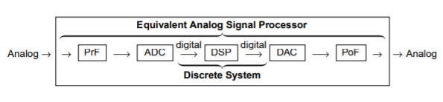

**2.3.2 ADVANTAGES OF DSP OVER ASP**

A major drawback of ASP is its limited scope for performing complicated signal-processing applications. This translates into nonflexibility in processing and complexity in system designs. All of these generally lead to expensive products. On the other hand, using a DSP approach, it is possible to convert an inexpensive personal computer into a powerful signal processor. Some important advantages of DSP are these:

1. Systems using the DSP approach can be developed using software running on a general-purpose computer. Therefore DSP is relatively convenient to develop and test, and the software is portable.

2. DSP operations are based solely on additions and multiplications, leading to extremely stable processing capability—for example, stability independent of temperature.

3. DSP operations can easily be modified in real time, often by simple programming changes, or by reloading of registers.

4. DSP has lower cost due to VLSI technology, which reduces costs of memories, gates, microprocessors, and so forth.

The principal disadvantage of DSP is the limited speed of operations limited by the DSP hardware, especially at very high frequencies. Primarily because of its advantages, DSP is now becoming a first choice in many technologies and applications, such as consumer electronics, communications, wireless telephones, and medical imaging.

**Chapter 3**

**Proposed system**

Recently, there are some intensive studies solving the energy efficiency problem in D2D communications. With respect to the D2D communications in unlicensed spectrum (out-band D2D communications), the authors in [26] exploited the network coding (NC) technique in bidirectional communications to propose an adaptive cooperative NC-based medium access control (ACNC-MAC) protocol for the out-band D2D communications. The simulation results demonstrated that this protocol can achieve improvements in terms of D2D throughput and energy efficiency. Moreover, the two MAC strategies based on game theory (i.e., distributed and coordinated approach) have been proposed for energy-efficient and rapid outband D2D content dissemination in 4G cellular networks. However, these studies did not consider the social relationship information of MUs, which influences the performance of D2D communications. This motivates us to take into account the mobile social networks for energy efficiency optimization problem in D2D communications underlaying 5G cellular networks.

In fact, research on exploiting social networking characteristics in D2D communications has just been started . Particularly, the authors in [28] utilized the contact time information, which is obtained through the social model, to maximize the resource utilization and network throughput in D2D-assisted cellular networks. However, this study only considered the contact time information for resource allocation problem, which is not sufficiently convincing. In [29], the authors proposed a solution based on the general cooperative game theory for social-aware resource allocation problem in order to maximize the social group utility in D2D communications. Similarly, the community characteristic of social networks has been exploited in [30] to propose an efficient resource allocation scheme for D2D communications underlaying cellular networks. Moreover, the cooperative D2D communications has been investigated under social networking perspectives in [31, 32]. Nevertheless, these works [28–32] mainly focused on exploiting the social relationships for resource allocation problem and cooperative D2D communications, without considering the energy efficiency in D2D communications. The work in [13] proposed a social-aware cooperative D2D-MAC protocol that utilizes social relationships to increase the energy efficiency in cooperative D2D communications. However, the authors in this work focused on the integration of social networks into MAC protocol design for green D2D communications without considering the physical interference management problem. Different from the aforementioned studies, we consider both the social relationships and physical interference between all MUs to improve the performance and increase the energy efficiency for D2D communications in 5G networks.

**3 System Model and Problem Formulation:**

This section will introduce the detailed system model and problem formulation, as well as the assumptions. To facilitate the readers, the important notations are shown in Table 1.

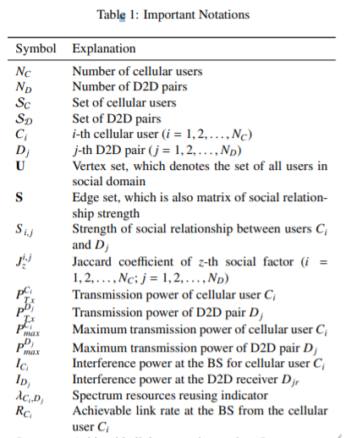

**3.1. System Model**

In this work, the social-aware D2D communications in 5G networks are considered as a combination of the physical domain and the social domain, as shown in Fig. 1. This system model will be described in details in the sequels.

**3.1.1. The Physical Domain**

In the physical domain, the users wish to set up D2D communication links to utilize the cellular resources depending on the physical and communication constraints [29]. Therefore, we consider the D2D communications model in 5G networks in a single cell scenario where the base station is located at the center and multiple cellular users or D2D pairs (i.e., transmitter and receiver) are randomly distributed.

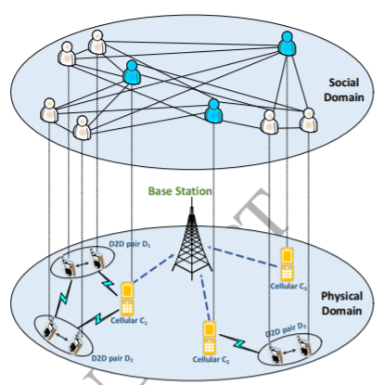

Figure 3: System model

In this model, we take into account the communication phase with assumptions that each cellular user will be allocated an orthogonal subchannel and D2D pairs can reuse the spectrum resources of cellular user in order to enhance the spectrum efficiency.

**3.1.2 Adaptive Genetic Algorithm Flow chart**

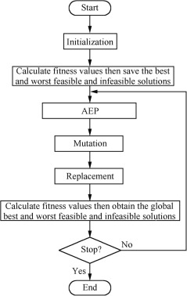

**3.1.3 Adaptive Genetic Algorithm**

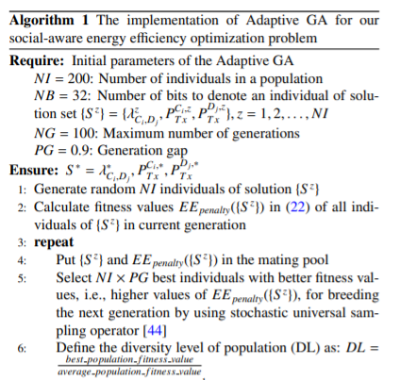

. Performance Evaluation In this section, we will introduce the numerical results to demonstrate the effectiveness of our proposed solution. 5.1. Parameter Setting In a single cell scenario, we deploy the system within a 500m×500m network area where the BS is located at the center and multiple cellular users/D2D pairs are randomly distributed. With D2D communications, the maximum distance between D2D transmitter and D2D receiver is set to be 25m. In order to illustrate the cellular users and D2D pairs in the simulation, we sketch the network layout with 3 cellular users and 5 D2D pairs, as shown in Fig. 3. We also set the path loss factor in Rayleigh fading channels as η = 3. The important parameters are shown in Table 2.

We implement the Adaptive GA with 100 generations to solve our social-aware energy efficiency optimization problem. From Fig. 4, we can see that the convergence of Adaptive GA holds quickly after around 20 generations when the mean fitness value of all individuals converges on the best fitness value. This result shows that the Adaptive GA are realizable to deal with our p

The Performance Metrics In this work, we evaluate the performance of our proposed social-aware energy efficiency optimization solution, denoted as “EEO”, by comparing the “EEO” with the other two socialunaware cases which are denoted as “ECP” and “RCP”. In “ECP” scheme, both the channel mode (i.e., cellular or D2D mode) and transmission powers are equally allocated to each user, independent of social relationships. However, they must satisfy the constraints in (19). Similarly, in “RCP” scheme, both the channel mode and transmission powers are randomly allocated to each user. The performance of all schemes, i.e., the energy efficiency and system throughput will be evaluated in the sequels.

The impact coefficient of social relationship strength α Fig. 5 and Fig. 6 depict the energy efficiency and system throughput in “EEO”, “ECP” and “RCP” schemes versus the impact coefficient of social relationship strength α, respectively. Here, we keep NC = 4, ND = 6 and vary α from 0.1 to 1.

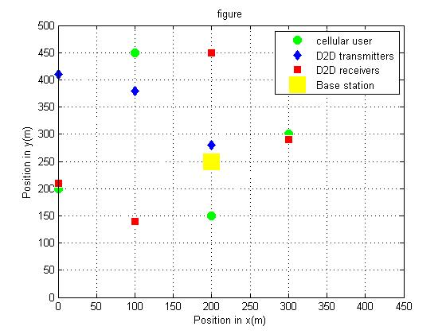

Fig 5 .Network Layout

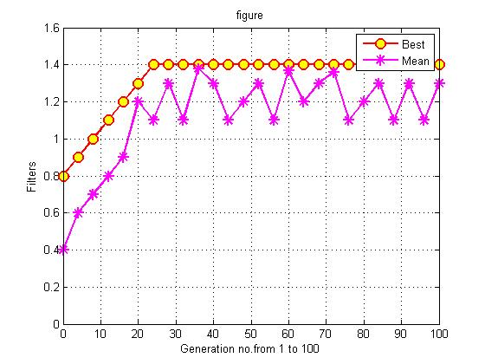

Fig 6: Convergence Rate of Adaptive GA

The results in Fig. 5 indicate that the energy efficiency in our proposed “EEO” scheme increases with increasing the impact coefficient of social relationship strength α. The reason is that, when the impact coefficient of social relationship strength is stronger the cooperation in D2D communications will be more effective, leading to an increase in energy efficiency. Moreover, our proposed “EEO” always gains the best energy efficiency performance, i.e., 36% and 53% better than the “ECP” and “RCP” schemes, respectively. We also see in Fig. 6 that the system throughput in our proposed “EEO” outperforms that in the “ECP” and “RCP” schemes. These are because that our proposed “EEO” considers both the social relationships and physical interference between all MUs to improve the performance of D2D communications, while “ECP” and “RCP” cannot. These evaluation results shown that considering the social relationships of mobile users can significantly improve the energy efficiency and system throughput in D2D communications.

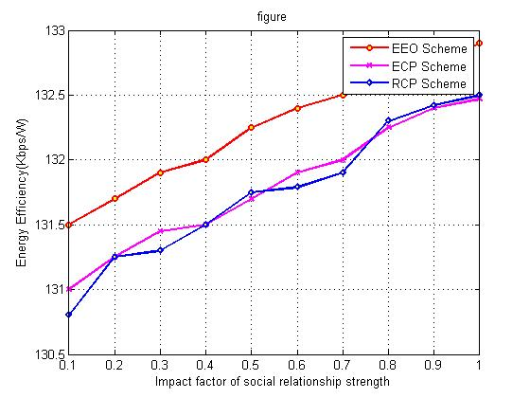

Fig 7: Energy Efficiency vs. α

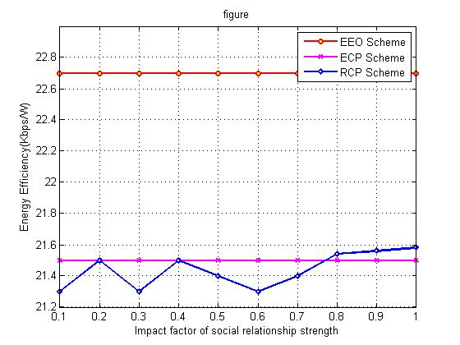

Fig 8:System Throughput vs. α

3.2.3 The number of cellular users NC

Furthermore, we also investigate the performance of “EEO”, “ECP” and “RCP” schemes under influence of the number of cellular users NC by keeping α = 1 and ND = 5 while varying NC from 2 to 20. As can be clearly observed in Fig. 7 and Fig. 8, increasing the number of cellular users NC results in an enhancement in the energy efficiency and system throughput since more resource sharing opportunity in D2D communications can be obtained. In comparison, our proposed “EEO” scheme also achieves the highest energy efficiency and system throughput compared with “ECP” and “RCP” schemes because the optimization solution improves the system performance. Especially, the amplitude of effectiveness increases with the number of cellular users NC. For example, the energy efficiency in our proposed “EEO” scheme is enhanced by 21% when NC = 4 and 92% when NC = 14 (Fig. 7). This is because when the number of cellular users NC is larger then the effectiveness of optimization solution becomes better. In other words, the proposed social

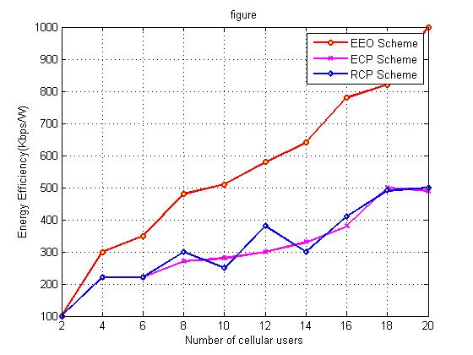

Fig9: Energy Efficiency vs. NC

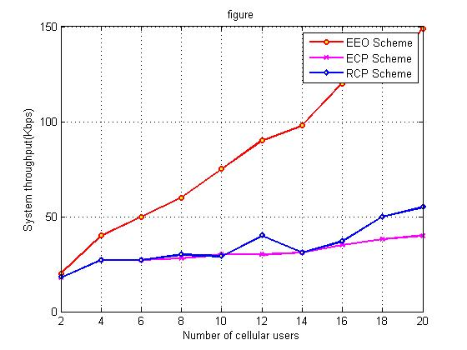

Fig 10:System Throughput vs Nc

aware energy efficiency optimization solution will achieve remarkable improvements in terms of energy efficiency and system throughput when there are more cellular users in the networks.

**3.2.4. The number of D2D pairs ND**

Finally, we keep α = 1 and NC = 5 while varying ND from 4 to 12, aiming to evaluate the performance of “EEO”, “ECP” and “RCP” schemes under influence of the number of D2D pairs ND. As can be clearly seen from Fig. 9 and Fig. 10, when increasing the number of D2D pairs ND, both the energy efficiency and system throughput in “ECP” and “RCP” schemes considerably drop (about 92%) while our “EEO” scheme slightly increases (about 30%). The reason is that, in “ECP” and “RCP” schemes, when the number of D2D pairs ND increases, the mutual interference between cellular user and D2D user increases, leading to a decrease in energy efficiency and system throughput. Meanwhile our proposed “EEO” scheme considers the mutual interference problem effectively to improve the system perfort

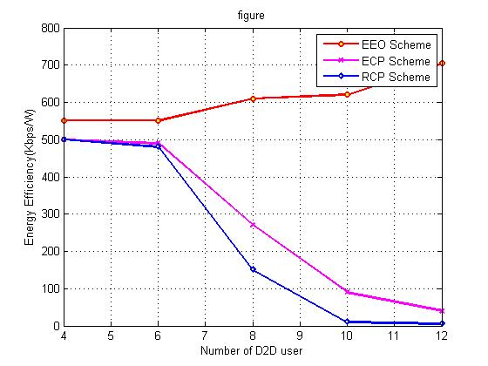

Figure 11. Energy Efficiency vs­­­. ND

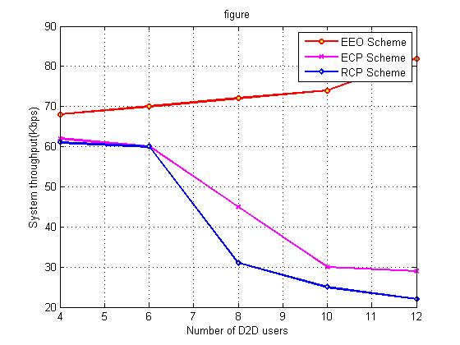

Figure 12:System Throughput vs. ND

Furthermore, our proposed “EEO” scheme is always the best solution with the highest energy efficiency and system throughput compared with the other two schemes thanks to the optimal mode selection and transmission powers allocation. These observations demonstrated that our proposed social-aware energy efficiency optimization solution also significantly improves the performance of D2D communications under different number of D2D pairs in the networks.

**References:**

[1] J. Qiao, X. S. Shen, J. W. Mark, Q. Shen, Y. He, L. Lei, Enabling device-to-device communications in millimeter-wave 5G cellular networks, IEEE Communications Magazine 53 (1) (2015) 209–215. doi: 10.1109/MCOM.2015.7010536.

[2] M. Chen, Y. Hao, L. Hu, K. Huang, V. K. N. Lau, Green and mobilityaware caching in 5G networks, IEEE Transactions on Wireless Communications 16 (12) (2017) 8347–8361. doi:10.1109/TWC.2017.2760830.

[3] L. Jiang, H. Tian, Z. Xing, K. Wang, K. Zhang, S. Maharjan, S. Gjessing, Y. Zhang, Social-aware energy harvesting device-to-device communications in 5G networks, IEEE Wireless Communications 23 (4) (2016) 20–27. doi:10.1109/MWC.2016.7553022.

[4] Y. Hao, M. Chen, L. Hu, J. Song, M. Volk, I. Humar, Wireless fractal ultra-dense cellular networks, Sensors 17 (4) (2017) 841–848. doi:10. 3390/s17040841. URL <http://www.mdpi.com/1424-8220/17/4/841>

[5] M. N. Tehrani, M. Uysal, H. Yanikomeroglu, Device-to-device communication in 5G cellular networks: challenges, solutions, and future directions, IEEE Communications Magazine 52 (5) (2014) 86–92. doi: 10.1109/MCOM.2014.6815897.

[6] M. Noura, R. Nordin, A survey on interference management for deviceto-device (d2d) communication and its challenges in 5g networks, Journal of Network and Computer Applications 71 (2016) 130 – 150. doi:http://dx.doi.org/10.1016/j.jnca.2016.04.021. URL http://www.sciencedirect.com/science/article/pii/ S1084804516300753

[7] N. Panwar, S. Sharma, A. K. Singh, A survey on 5G: The next generation of mobile communication, Physical Communication 18, Part 2 (2016) 64 – 84, special Issue on Radio Access Network Architectures and Resource Management for 5G. doi:https://doi.org/10.1016/j.phycom.2015.10.006. URL http://www.sciencedirect.com/science/article/pii/ S1874490715000531

[8] M. Chen, Y. Miao, Y. Hao, K. Hwang, Narrow band Internet of Things, IEEE Access 5 (2017) 20557–20577. doi:10.1109/ACCESS.2017. 2751586.

[9] H. A. U. Mustafa, M. A. Imran, M. Z. Shakir, A. Imran, R. Tafazolli, Separation framework: An enabler for cooperative and D2D communication for future 5G networks, IEEE Communications Surveys Tutorials 18 (1) (2016) 419–445. doi:10.1109/COMST.2015.2459596.

[10] M. Chen, J. Yang, Y. Hao, S. Mao, K. Hwang, A 5G cognitive system for healthcare, Big Data and Cognitive Computing 1 (1) (2017) 1471–1484. doi:10.3390/bdcc1010002. URL <http://www.mdpi.com/2504-2289/1/1/2>